Final Document

**Accessibility in Microsoft Teams for Surface Dyslexia Users**

**Team Dslexia**

Dhanshri, Dristi, Kunal, Mandar, Stella

Table of Content

**Vision 3**

**Target groups 3**

Why we chose this group 3

**Why we picked Microsoft Teams 4**

Existing features for users 5

Problems users face 5

**User Needs 6**

Research 6

**Business Goals 7**

**Competitive Research 7**

**Initial Ideas 8**

**Testing Plan 11**

**Scaling 11**

Immersive Reader Across Microsoft Office Suite 11

Auto-Complete Across Microsoft Communication Tools 11

Benefits of Scaling 12

Considerations for Scaling 12

Iterative Improvement 12

**MVP Features 12**

**Roadmap 17**

Longer term strategy 19

Unsolved Questions 20

Presentation link: <https://www.canva.com/design/DAF1lB-DDPQ/wqks7wjawxa3Vpv9-b8N4A/edit?utm_content=DAF1lB-DDPQ&utm_campaign=designshare&utm_medium=link2&utm_source=sharebutton>

# Vision

Our goal is to enhance Microsoft Teams desktop experience to empower junior-level employees with surface dyslexia in English, ensuring seamless collaboration and a sense of inclusion for all.

# Target groups

Our target user group is junior-level employees with surface dyslexia who are proficient in English.

## Why we chose this group

**Surface dyslexia** is a type of dyslexia characterized by difficulty with whole-word recognition and spelling. They frequently find themselves compelled to navigate educational and work settings that do not cater to their specific needs. Unfortunately, this situation often results in them being unjustly characterized as "incompetent" or "unintelligent" by both educators and parents. Some difficulties they face are:

* Difficulty with whole word recognition
* Difficulty with reading, spelling and writing
* Slow to read
* Difficulty reading new words by sight

We discovered that **junior-level** employees tend to encounter more challenges with spelling and writing. This difficulty often arises from their involvement in meetings, requiring detailed note-taking and a heightened focus on spelling and grammar. Consequently, we believe that junior-level working adults with dyslexia would significantly benefit from targeted improvements within Teams.

Our primary focus for implementing these enhancements is on both new and experienced users of Microsoft Teams who are proficient in **English**. The reasoning behind this choice is due to the widespread use of English as a global business language, aligning with the current demographic data for Microsoft Teams, where a significant portion of users communicate primarily in English and little research for other languages. Knowing this information makes sense to start with English and this way we can address the immediate needs of a large user base, ensuring a more inclusive and accessible experience for individuals with dyslexia who may face language-related challenges in professional settings.

How our target users currently solve these problems?

As for right now they would use external tools or applications that offer dyslexia-friendly features to compose messages or documents before pasting them into Teams.Some users also rely on colleagues or assistive technologies to help with spelling and grammar checks.They also try and avoid certain features in Teams that might have challenges, limiting their full participation in meetings or discussions.

# Why we picked Microsoft Teams

Microsoft Teams is the ultimate messaging app for your organization—a workspace for real-time collaboration and communication, meetings, file and app sharing, and even the occasional emoji! All in one place, all in the open, all accessible to everyone (Welcome to Microsoft Teams, n.d.).

When using Microsoft Teams, they might see text appearing to jump around on a page, and not be able to tell the difference between letters that look similar.

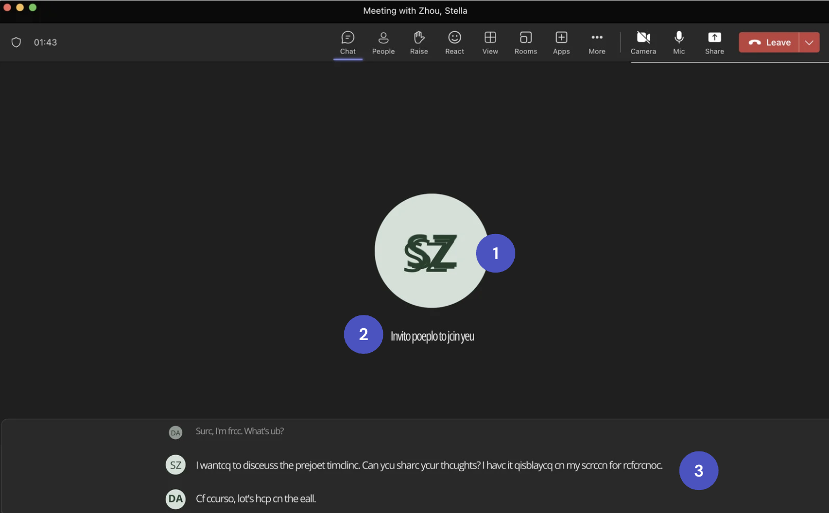

Dyslexic persons view of teams

## 

People with surface dyslexia rely on spelling-sound correspondence too heavily. For them, words that cannot be sounded out (irregular words) are misread or misspelled.

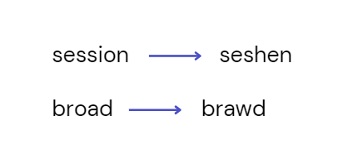

Dyslexic tendency to misspell

## Existing features for users

Use captions and transcription

* Captions and transcriptions provide options to see text as well as, or instead of, audio content.

Reduce distractions

* Adjust your notification settings and use custom backgrounds to help everyone stay focused.

Participate your way

* Choose how you contribute to the conversation with chat, live reactions, hand raising, and other features.

Immersive reader

* After the meeting ends the transcript can be downloaded and the immersive reader can be used on the downloaded transcript but not in real time in the meeting.

## 

## Problems users face

Text Customization

* Dyslexic users may struggle with text size, line spacing and background colors.

Visual Clutter Reduction

* Dyslexic users may find numerous features and messages overwhelming and hard to focus on the content they need.

Multitasking Challenges

* They may find it difficult to juggle between multiple chats, meetings, and documents within Teams.

Communication Anxiety

* Dyslexic users may experience anxiety when communicating in text or during video meetings, which can affect their participation and confidence.

Spelling and Grammar

* Dyslexic individuals may struggle with spelling and grammar.

Typing Speed

* Some users may type more slowly or make more typing errors

## 

# User Needs

## Research

To understand the real needs of the user, a lot of papers, articles and blogs were studied and it helped us to have a good understanding of the problems faced by the user in their work life and their needs to mitigate those problems.

Reddit and Quora threads were also studied where people with surface dyslexia have described the problems they face on a regular basis at work. The users have also posted suggestions for enhancements that should be made to teams to make it more user friendly for people who have surface dyslexia.

This process gave a good understanding of the user needs and combined with the most requested or most common suggestions made by users on reddit and quora, we could infer the important user needs.

They need features in Teams Desktop to alleviate reading and writing difficulties and assist with processing things:

* A feature that provides contextual guides for challenging words, aiding their comprehension and retention of the content.
* The option of enabling users to process meeting content at a more suitable pace.
* An enhanced chat and messaging support to empower them to communicate with confidence, ensuring that their written messages are accurate and error-free.

# Business Goals

The team also wanted to make sure that the changes we would make to the platform would align with the organizational goals of Microsoft. The changes proposed would help Microsoft to achieve the following goals:

* **Corporate Social Responsibility**

Microsoft’s commitment of building a responsible future includes protecting fundamental rights, this includes expanding accessibility and connectivity.

* **Accessibility innovation**

Microsoft strives to accelerate innovation to build a more equitable and accessible future for everyone.

# Competitive Research

* **Immersive Reader**

Microsoft's Immersive Reader is a free tool, built into Word, OneNote, Outlook, Office Lens, Reading Progress, Forms, Flip, Minecraft Education and the Edge browser, that implements proven techniques to improve reading and writing for people regardless of their age or ability.

* **Text-to-speech feature to read text aloud**

Speak is a built-in feature of Word, Outlook, PowerPoint, and OneNote.

* **Focused Inbox**

Outlook offers a Focused Inbox feature that helps users focus on important emails, potentially reducing information overload for users with dyslexia.

# Initial Ideas

A number of potential features were decided based on the problems solved for the users and the nature in which they were solved.

**Idea #1**

Simplified Event Creation: helpful tooltips and guidance during the event creation process.

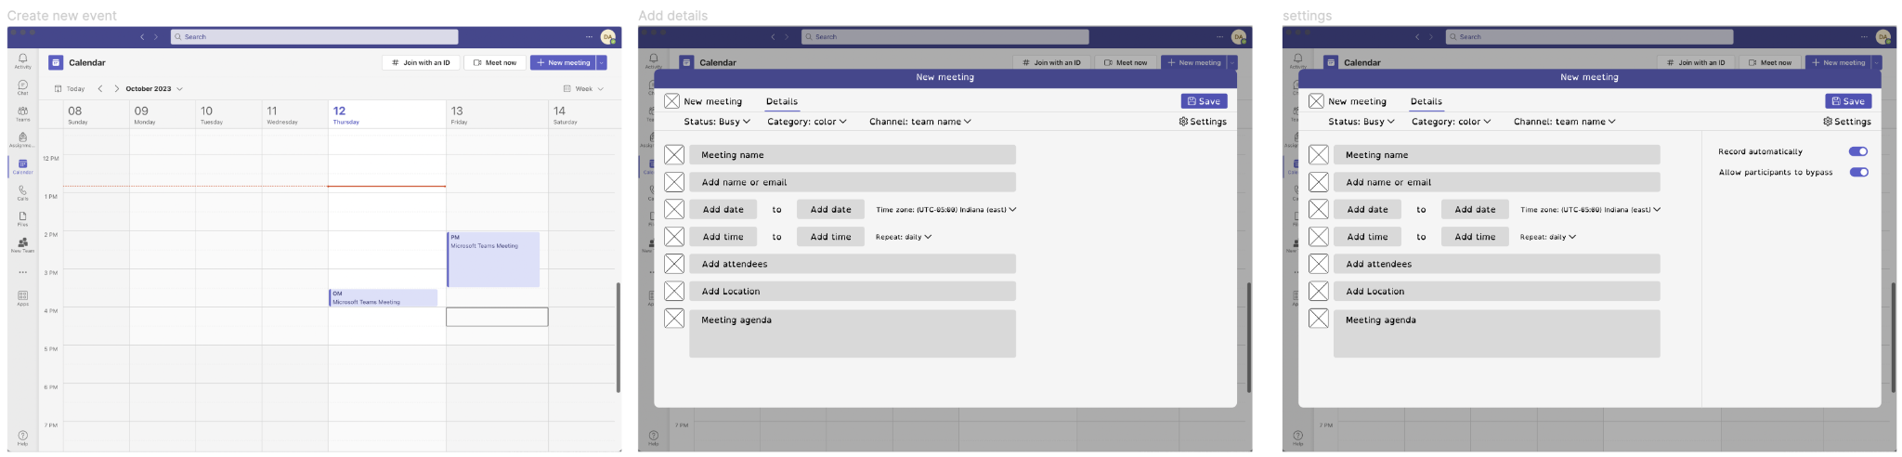

**Idea #2**

Adding slow mode to live captions. It would show more than two sentences at a time, the older sentences will be smaller to indicate its fading life span.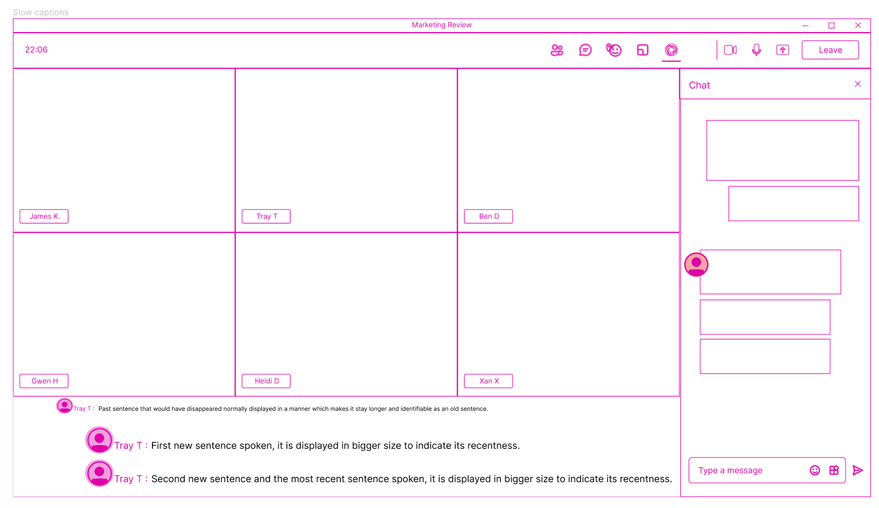

**Idea #3**

Integrate Immersive reader into live captions and transcript.

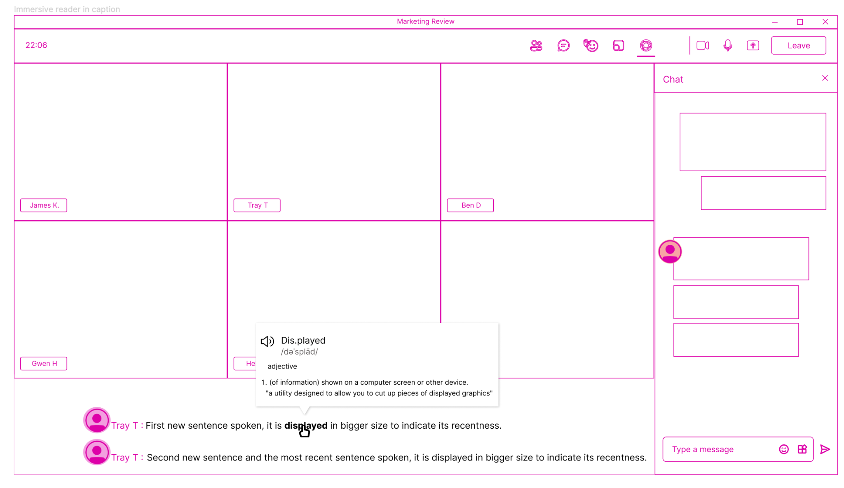

**Idea #4**

Adding spell check and auto-correct to live chat, similar to outlook. Auto complete to predict and suggest the next word.

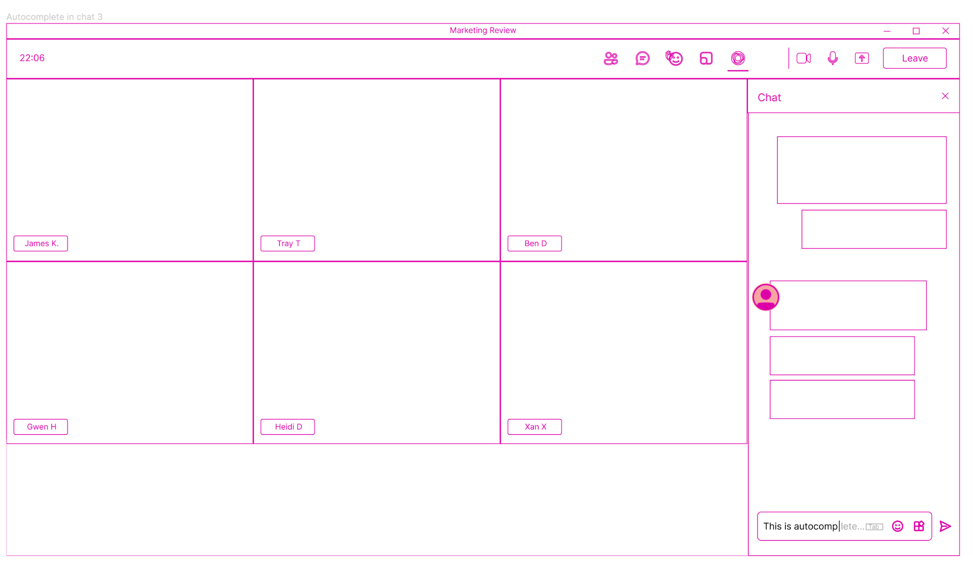

**Idea #5**

Addition of the ability to pin captions of importance that will stay up as long as pinned.

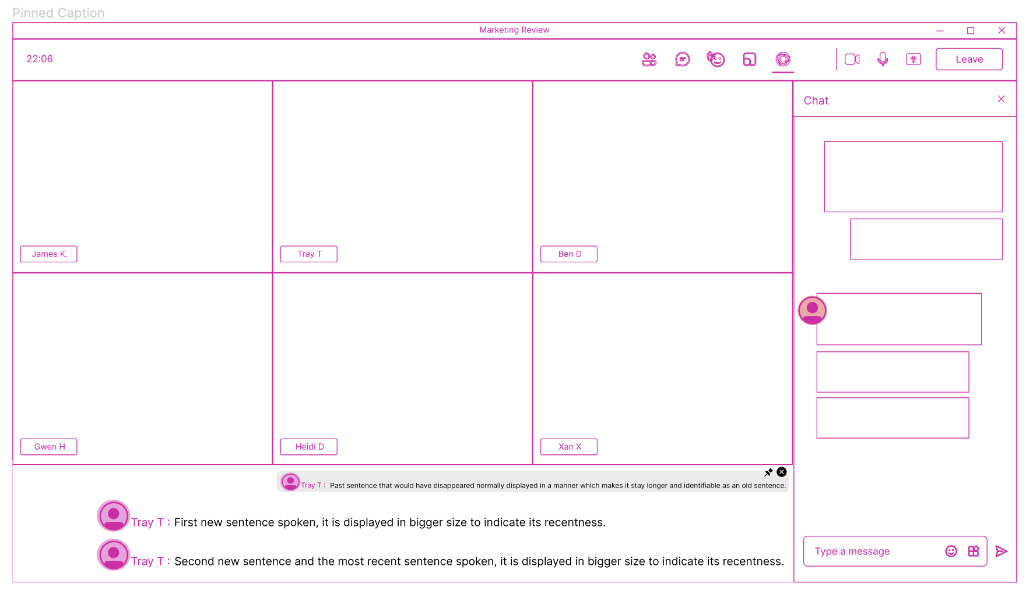

# Testing Plan

After thorough group discussions, we decided to use **heuristic evaluation** as our testing method. This framework is founded on the principles derived from the collective input of both user needs and business requirements. To assess the viability of our ideas, we employ a scaling system ranging from 1 to 7 for each principle.

In a collaborative effort, we extended invitations to professionals from Group 1, who also design for individuals with dyslexia, to provide their invaluable expertise and feedback. Following the evaluation process, we will identify and prioritize the top three ideas based on the cumulative scores.

We opted for Google Forms to make the testing protocol more accessible. You can find the heuristic evaluation testing protocol here: <https://forms.gle/WCh47Vtqe143QMpe9>

# Scaling

The Immersive Reader and Auto-Complete features, initially developed for Microsoft Teams to enhance accessibility for users with surface dyslexia, can be strategically scaled across various Microsoft products to create a consistent and inclusive user experience.

### Immersive Reader Across Microsoft Office Suite

Integrating the Immersive Reader feature across the Microsoft Office Suite can greatly aid users in comprehending content while they create documents. For example, in Excel, it ensures better accessibility to data, helping users understand and analyze information more effectively.

### Auto-Complete Across Microsoft Communication Tools

Extending the Auto-Complete feature to various Microsoft communication tools would significantly enhance the user experience. Users can benefit from Auto-Complete when adding content to slides in PowerPoint, making the creation of engaging presentations easier and more efficient. Additionally, implementing Auto-Complete for speaker notes in presentations and applying it to comments and annotations fosters collaboration and streamlines the feedback process. These adaptations ensure a consistent and helpful Auto-Complete experience across different communication and presentation platforms.

## Benefits of Scaling

* Consistency: Users will experience a consistent set of features across Microsoft products, promoting familiarity and ease of use.
* Unified User Experience: Immersive Reader and Auto-Complete become integral parts of the Microsoft ecosystem, creating a seamless and unified experience for users with diverse needs.
* Productivity: Users can leverage these features seamlessly across various tasks and applications, enhancing productivity and collaboration.

## Considerations for Scaling

* Cross-Platform Compatibility: Guarantee that these features work seamlessly across different platforms, including desktop, web, and mobile applications.
* User Education: Provide comprehensive documentation and user education materials to assist users in understanding and maximizing the benefits of these features.

## Iterative Improvement

* User Feedback Integration: Continuously gather user feedback across all scaled products to identify areas for improvement.
* Feature Iteration: Iterate on the features based on user feedback, evolving them to meet the evolving needs of users with dyslexia and other accessibility requirements.
* Collaboration with Communities: Engage with user communities and disability organizations to understand specific needs and challenges, informing future iterations and scaling efforts.

# MVP Features

The set of features originally decided were put through a rigorous evaluation process where each of the features were evaluated and rated on a scale of 1 to 7 based on different aspects like importance of problem solved, impact of feature, cognitive accessibility, cost to build, and adaptability. Based on the evaluation score the features were prioritized and the top features were selected as the MVP features.

These features are important as in the current situation the use of digital business communication platforms like Microsoft teams are at an all time high and with Microsoft Teams being the most popular platform within the product space it is imperative that teams be equally accessible for all users irrespective of any disability.

These features also allow Microsoft to move closer to achieving their goals of increasing Corporate Social Responsibility as Microsoft’s commitment of building a responsible future includes protecting fundamental rights, this includes expanding accessibility and connectivity and increasing accessibility innovation as Microsoft strives to accelerate innovation to build a more equitable and accessible future for everyone.

The MVP features are:

**#1 Immersive reader integration**

Integrating Immersive Reader into live captions and transcripts to help the users read difficult words and understand any new words. The users will be able to improve their comprehension of the content shown via captions that they otherwise would have hard time doing especially if a word was used that they don't usually come across. Before this feature the users didn't have much choice to help them read in that instant as they would have to download the transcript after the meeting had ended and use an immersive reader then. This feature will help the user while in the meeting itself, they won't have to wait. This feature will be a breakthrough as there aren't any real solutions to the problem nor any competitor has released any solution for it yet.

*Image 1:Select keyword*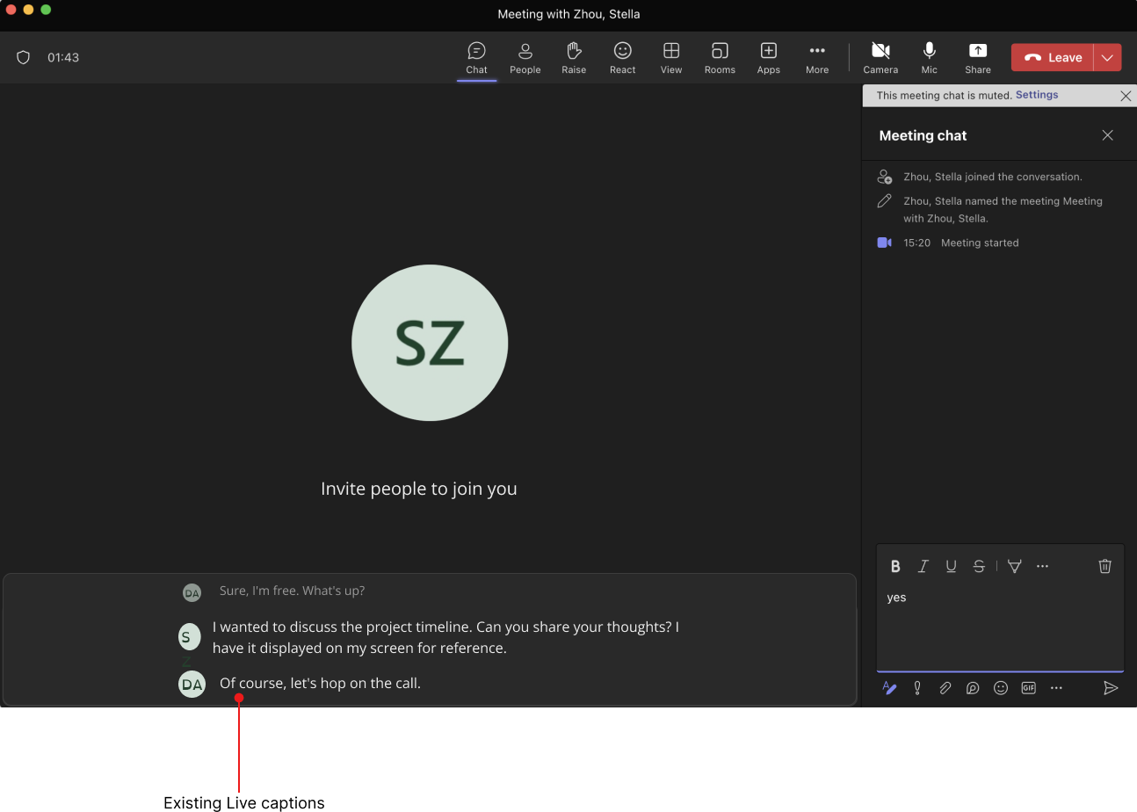

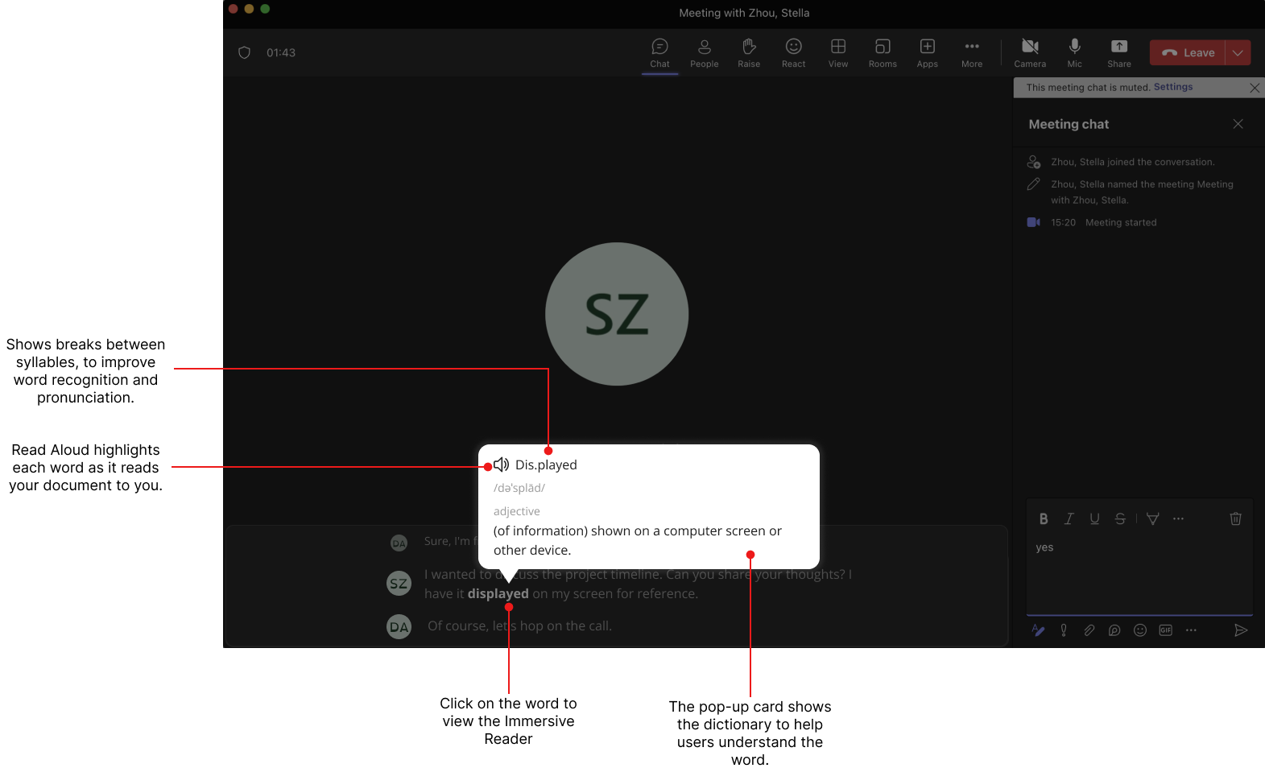

*Image 2: View dictionary*

**OKR**

This feature aims to help users read new or obscure words by implementing immersive readers functionality in live captions thereby improving the rate of comprehension for the user.

**Results**

* The average user comprehension should increase when using the accessibility features such as immersive reader in closed captions.
* Should achieve an average rating of > 3.5 /5 in the feedback.

**North Star**

The number of users that are English speaking working adults at a junior level position that have surface dyslexia.

**#2 Auto-complete**

Integrating the Auto-complete feature into live chat to predict and suggest the next word, similar to Outlook. This will assist users in reducing their spelling mistakes. The users will be able to send text messages at a faster pace with less spelling errors that they otherwise would have hard time doing. The users would use speech to text features to help with the typing but being in a meeting where the mic can be already engaged this would be useless . This feature will help the user while in the meeting regardless of whether the mic is available, they won't have to rely on the mic or worry if they are unmuted and are talking when they shouldn't. This feature can be seen in smartphone applications of teams where the operating system provides the feature. Having it built-in into teams desktop application will make it so much easier and convenient for the user.

*Image 3: Start writing in the chat*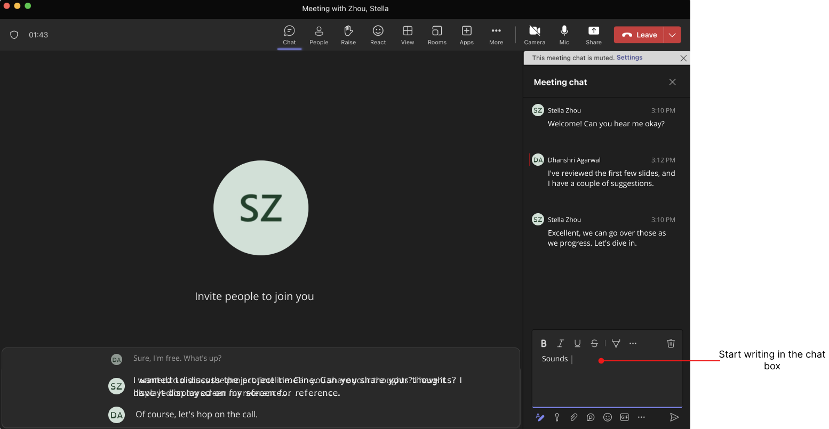

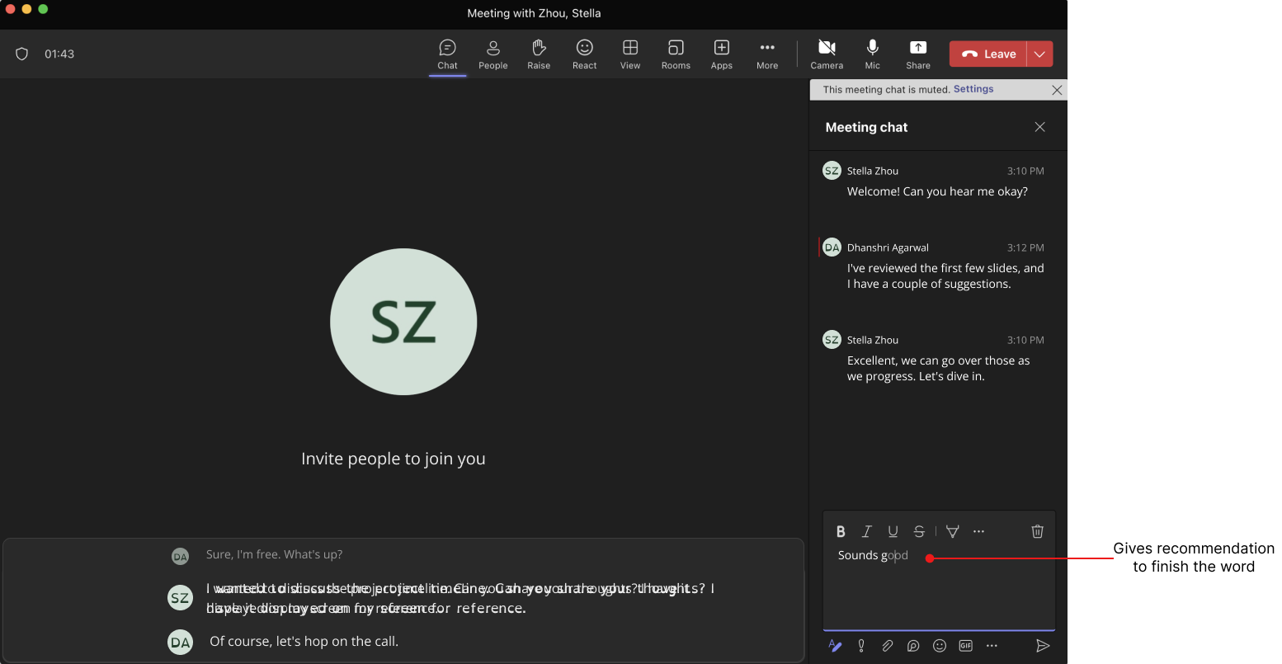

*Image 4: Gives recommendation to finish the word*

**OKR**

This feature aims to help users make less spelling errors while sending a text message within a meeting by implementing MS Word’s auto complete functionality in live chat.

**Results**

* The average total spelling errors should decrease.
* The user confidence in using and writing irregular words should increase
* Should achieve an average rating of >3.5 /5 in the feedback.

**North Star**

The number of text messages with no spelling errors sent in a meeting using the live chat feature by the users.

# Roadmap

Our plan to make Microsoft Teams accessible to everyone is divided into 3 segments, namely, short, mid, and long-term goals:

* In the next short term (6-12 months), the focus could be on forming partnerships with educational institutions and engaging with communities, sponsoring events by disability groups. During this time, important features like "Pinning Captions" and "Slow Mode for Live Captions" can be incorporated to improve real-time communication.
* Moving into the mid-term (1-2 years), the focus could be on introducing a dyslexia-friendly font and improving written communication with an "Auto-Complete" feature in live chat. Users will also get customization options to personalize their interface based on their needs, along with audio and visual preferences for an enhanced experience.
* Looking at the long-term (3-5 years), the aim is to integrate a dedicated feedback tool in Microsoft Teams, ensuring ongoing communication with users. This could be achieved by the connections formed during the short term goals of engaging with communities, and working with disability organizations and influencers to spread awareness.

**Short Term** (6-12 Months): Forming Partnerships and Initial Feature Rollout

1. Quarter 1-2: Development Kickoff and Immersive Reader Integration

* Assemble development teams.
* Define technical specifications.
* Begin Immersive Reader integration development.

1. Quarter 3-4: Auto-Complete Development and Testing

* Develop Auto-Complete feature.
* Integrate both features into a combined version.
* Release beta version for user testing.

1. Quarter 5-6: Release and Community Engagement

* Release integrated features to all Microsoft Teams desktop users.
* Engage with educational institutions and disability-focused organizations.
* Sponsor events and engage with communities.
* Collect feedback and insights from users for ongoing improvements.

**Mid-Term** (1-2 Years): Enhanced Features and Customization Options

1. Quarter 7-8: Dyslexia-Friendly Font and Customization Options

* Introducing dyslexia-friendly font.
* Enhance customization options for interface personalization.
* Conduct usability testing with users.

1. Quarter 9-10: Accessibility Audits and Performance Optimization

* Conduct comprehensive accessibility audits.
* Optimize performance based on user feedback.
* Monitor key performance indicators for feature success.

1. Quarter 11-12: Security and Compliance Testing and Full Feature Rollout

* Ensure compliance with accessibility standards.
* Gradually roll out feature enhancements based on user feedback.

**Long Term** (3-5 Years): Ongoing Improvement and Feedback Integration

1. Quarter 13-14: Engagement with Disability Organizations and Feedback Tool Development

* Strengthen connections with disability organizations.
* Collaborate on awareness campaigns.
* Initiate development of a dedicated feedback tool.

1. Quarter 15-16: Integration of Feedback Tool and Iterative Enhancements

* Integrate the dedicated feedback tool into Microsoft Teams.
* Establish a feedback loop for ongoing communication.
* Continue iterative enhancements based on user feedback and evolving needs.

1. Quarter 17-18: Continued Awareness and Future Planning

* Sustain community engagement and awareness initiatives.
* Reflect on long-term success metrics.
* Set new goals for ongoing accessibility enhancements.

## Longer term strategy

**Long-Term Goal: Achieving Universal Accessibility in Microsoft Teams**

At the heart of our vision lies the commitment to create a digital environment where every individual, regardless of their abilities, experiences equal opportunities and participation. Our long-term aspiration is to foster inclusivity within Microsoft Teams, ensuring that all users, irrespective of physical, cognitive, or sensory differences, can seamlessly engage, collaborate, and thrive within the platform.

* **Equity Through Accessibility**: We are dedicated to curtailing inequity by dismantling barriers that impede access to information, communication, and collaboration tools. Our goal is not merely compliance but rather an unwavering dedication to ensuring a level playing field for every user, fostering an environment where diverse abilities are accommodated, respected, and celebrated.
* **Empowering Every User**: By prioritizing accessibility initiatives within Microsoft Teams, we aim to empower users with varying abilities to navigate the platform with confidence, leveraging features tailored to their needs. Our focus extends beyond conventional accessibility standards; we aim to anticipate and address diverse user requirements, delivering an experience that is intuitive, customizable, and empowering for all.

Based on the long-term goal, we have developed an Opportunity Solution Tree to delineate the envisioned outcomes, opportunities, and corresponding solutions, presented in Figure 1.

Figure 1

[Opportunity Solution Tree](https://www.figma.com/file/L3IkCUbAPIt3TX5C2EUNlr/Roadmap?type=whiteboard&node-id=0%3A1&t=w2nn72CrCyvD4uNT-1)

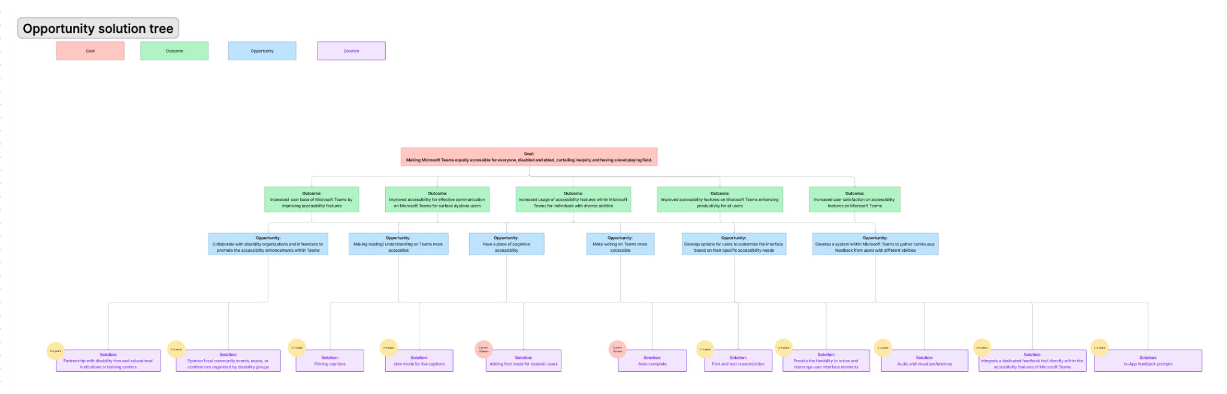

The main outcomes include:

* **Expanded User Base**: Enhance accessibility features to attract and accommodate a wider range of users, thereby increasing the overall user base of Microsoft Teams.
* **Enhanced Usage of Accessibility Features**: Encourage increased utilization of accessibility tools and features within Microsoft Teams among individuals with diverse abilities, fostering a more inclusive environment.
* **Augmented Productivity through Accessibility**: Enhance the accessibility features on Microsoft Teams to boost productivity and streamline usage for all users, irrespective of their abilities.
* **Heightened User Satisfaction**: Elevate user satisfaction levels by refining and optimizing accessibility features within Microsoft Teams, ensuring a more fulfilling experience for all users.
* **Tailored Accessibility for Surface Dyslexia Users**: Improve accessibility specifically for individuals with surface dyslexia to facilitate more effective communication within Microsoft Teams.

## Unsolved Questions

What problems do your features still leave unsolved?

* **Language Limitation:** The features are initially focused on English-speaking users due to the widespread use of English in professional settings. Users working in other languages may still face challenges.
* **Platform Limitation**: The proposed features may not cover all functionalities or aspects of Teams, and users may encounter accessibility issues
* **User Adoption:** Some users may resist or find it challenging to adopt new features initially, and there may be a learning curve associated with the integration of Immersive Reader and Auto-Complete.